API Gateway

Available APIs

Update Salesforce 49.0
Prior State
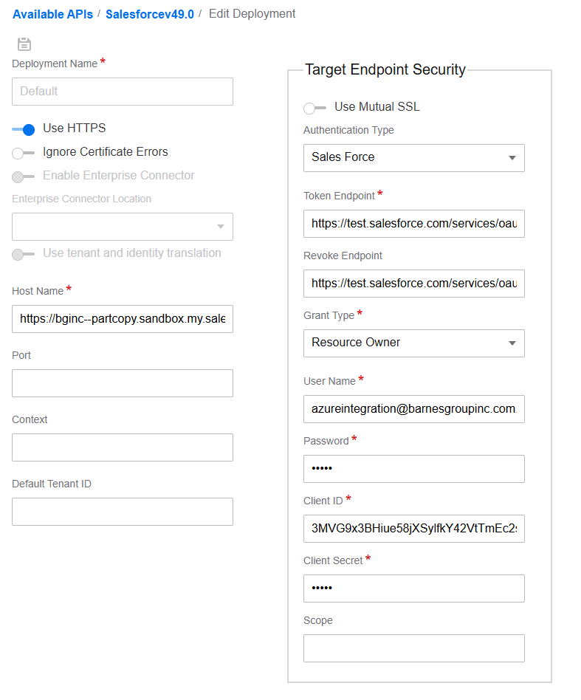
Host Name
Was: https://bginc--partcopy.sandbox.my.salesforce.com
Changed To: https://bginc.my.salesforce.com
Token Endpoint
Was: https://test.salesforce.com/services/oauth2/token
Now: https://login.salesforce.com/services/oauth2/token

Revoke Endpoint
Was: https://test.salesforce.com/services/oauth2/revoke
Now: https://login.salesforce.com/services/oauth2/revoke

Client ID
Was: 3MVG9x3BHiue58jXSylfkY42VtTmEc2smoqTaTpbGpAwIDOV3X_RV8IVtZx.Y80mSnnDOn47ooFJWQPA_zjOi
Now: 3MVG9LBJLApeX_PBNZD0VDtU2EnyzsRZLRYtq_rzD_.VgsUUtVFOmAe62hDzCBe88a5aHTcH4.D35fJCatqpq

Authorized Apps

M3_Salesforce_Web_Service_PC
Redirect URL
Was: https://bginc--partcopy.sandbox.my.salesforce.com/services/authcallback/IMSEndpoint
Now: https://bginc.my.salesforce.com/services/authcallback/IMSEndpoint

ION
Connection Points
Updated login to new one we created in this video
Salesforce - M3 Service Accounts-20250821_085449-Meeting Recording.mp4
SVCSFPRD_M3RA@asraymond.com

